**Marion Halliday**

**Bluegrass and Bourbon-Infused**

**Women-Powered Original Americana**

[marionshalliday@yahoo.com](mailto:marionshalliday@yahoo.com)

www.marionhalliday.com

**Rings Around Saturn**

July 2019 debuts at

**#3 Album**  **#3 Artist** July 2019*

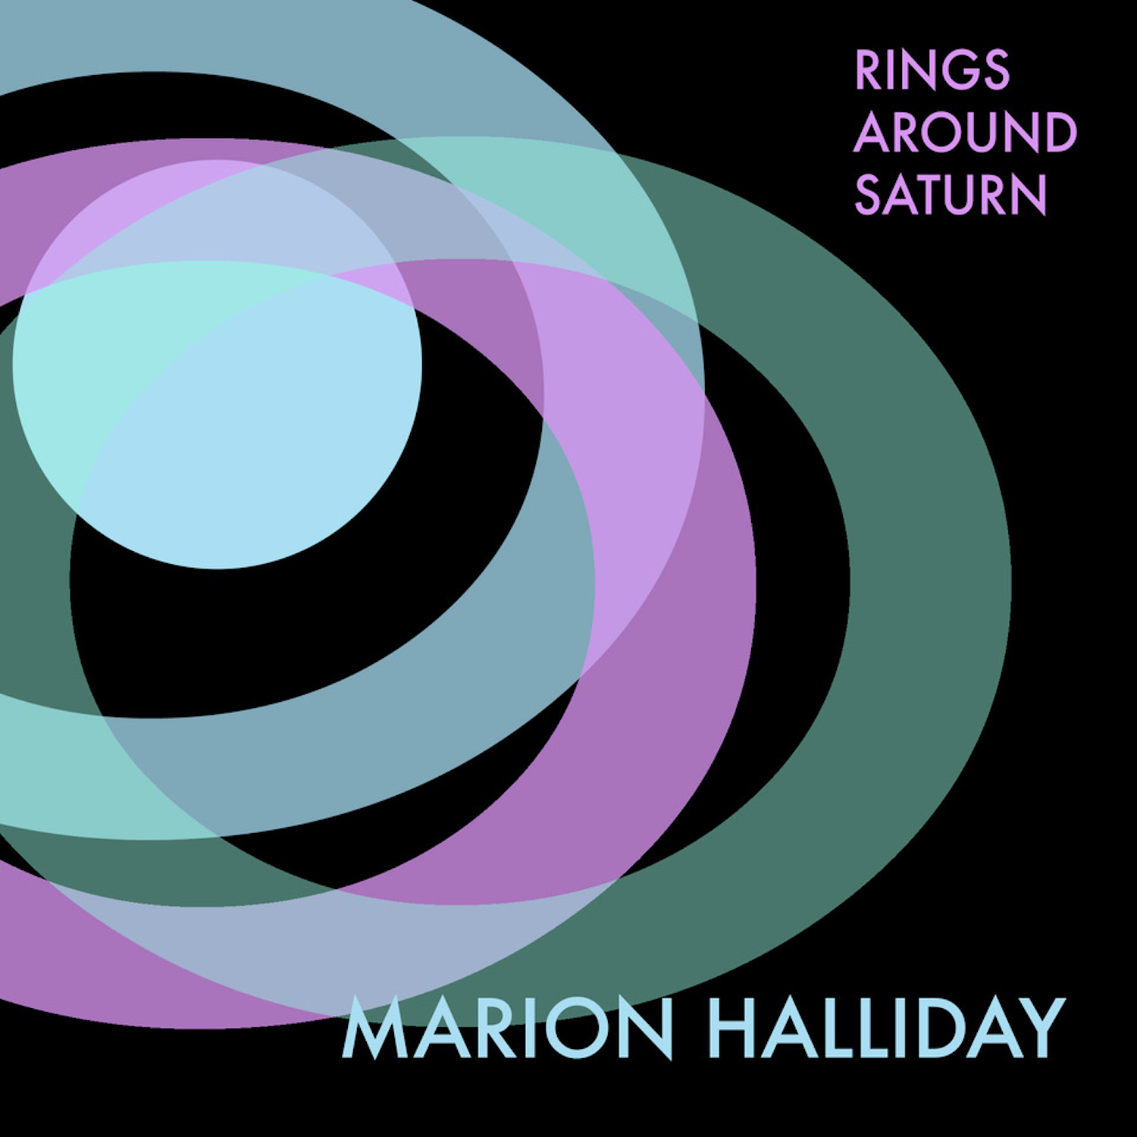

**Projects & Bands**- Marion has appeared solo and/or with her bands in dozens of fests and venues throughout the northeast, mid-Atlantic and mid-West as well as in Scotland and Mexico. Her bands & projects include

* ***Trickster Sister***-formed in 2016 with Donna Bostock (bass, percussion, vocals) and Marion’s sister, Jane Halliday (violin, banjo uke, vocals). The band has fast acquired a reputation for, in the words of one radio show host, ‘its enticing blend of original Americana, indie, folk, and bluegrass musical styles, with lush vocal harmonies over-top’ *(John Gage, Kentucky Homefront Radio Hour, WFPK FM)*.
* ***The Weeping Pints***- In Spring of 2021, Marion formed a new band, The Weeping Pints, with her Sister Jane and guitar player extraordinaire, Chris Fargen. This new band features a combo of Marion’s originals and pub-inspired music of the British Isles.
* ***‘Super Band’ Project with Meghan Cary*** – Also in Spring of 2021, Marion joined forces with Philly-based folk-rocker Meghan Cary to create a ‘Super Band’ to showcase both women’s music in a full band format. They are engaged in various joint recording projects and shows in the coming year!

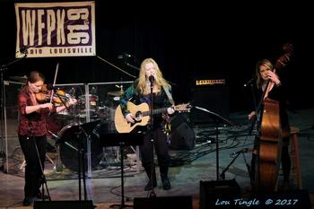

**LIVE Links To Video & Recordings\***

**Live Performances**

* [**NERFA Nov 2019 – If Statues Could Speak**](https://www.youtube.com/watch?v=VSPngGgsLK8)
* [**NERFA Nov 2018 – Bourbon and Men**](https://www.youtube.com/watch?v=lhbSWcQaf8Q)
* [**WFUV John Platt OTR Show 2020 – Rings**](https://www.youtube.com/watch?v=mgotNB4EACg)
* [**WFUV John Platt OTR Show 2020 –**](https://www.youtube.com/watch?v=JZ32cZePQiY) **Just Love**
* [**The Weeping Pints (Louisville KY 2021)**](https://www.facebook.com/527228085/videos/10159462913273086/)
* [**Philly Folksong Society (PFS Audience Singalong)**](https://www.youtube.com/watch?v=rEcWzas1w2k)

**Studio + Recent Home (Covid) Recordings**

* **[The Measure](https://www.youtube.com/channel/UCMcmQxykILRxUphK8XOIuww)**
* [**Rings Around Saturn**](https://www.youtube.com/watch?v=ytFPtIVcpAc)
* [**If Statues Could Speak**](https://www.youtube.com/watch?v=iC-LA6ZkhkI)
* [**Thoughts & Prayers**](https://www.youtube.com/watch?v=EppwPFq9Erw)
* [**Good Things Will Come**](https://www.youtube.com/watch?v=ZX62sbRsSC0)
* [**Time to Live Again**](https://www.youtube.com/watch?v=xD5L8ZX3wf4)

*Go to Marion’s website for more live video & recordings

**Lou Tingle @ 2017**

*Data compiled by Folk Radio International for July 2019

**Accolades**- In November 2019, Marion was a featured performer in the prestigious ‘Semi-Formal Showcase’ at the Northeast Regional Folk Alliance (NERFA) annual conference held in Stamford CT (a division of Folk Alliance International)

In January 2018, Marion was named ‘One of the Ones to Watch’ by the Nashville Songwriter’s Association International. Also in 2018, Marion was runner-up for Best of Philly Live Performer (Folk/Country Category); she was also a featured ‘DJ Showcase’ performer at the NERFA 2018 annual conference as the selection of Ron Olesko, WFDU ‘Traditions’ DJ.

Marion’s first solo full-length album, released July 2019, **Rings Around Saturn**, **debuted at #3** on US/International folk radio charts*. The album also made the FAI listing of Top Albums for 2019. The title track was described by one critic as ‘beautifully sung…a delicate and thoughtful piece that showcases a tremendous characterful vocal talent’*(Chris Porter, Stereo Stickman July 2019)*. Another critic, writing specifically about ‘Thoughts and Prayers’ (Track #2), described it as ‘miraculous, her voice is a new beacon of peace in this troublesome time.*’ (Joe Timmons, Indie Pulse July 2019)*.

**Here’s what critics have been saying:**

‘[B]eautifully sung…a delicate and thoughtful piece that showcases a tremendous characterful vocal talent’ - *Chris Porter, Stereo Stickman July 2019*

‘[Marion’s] songs are miraculous, her voice is a new beacon of peace in this troublesome time’*– Joe Timmons, July 2019 Indie pulse Music*

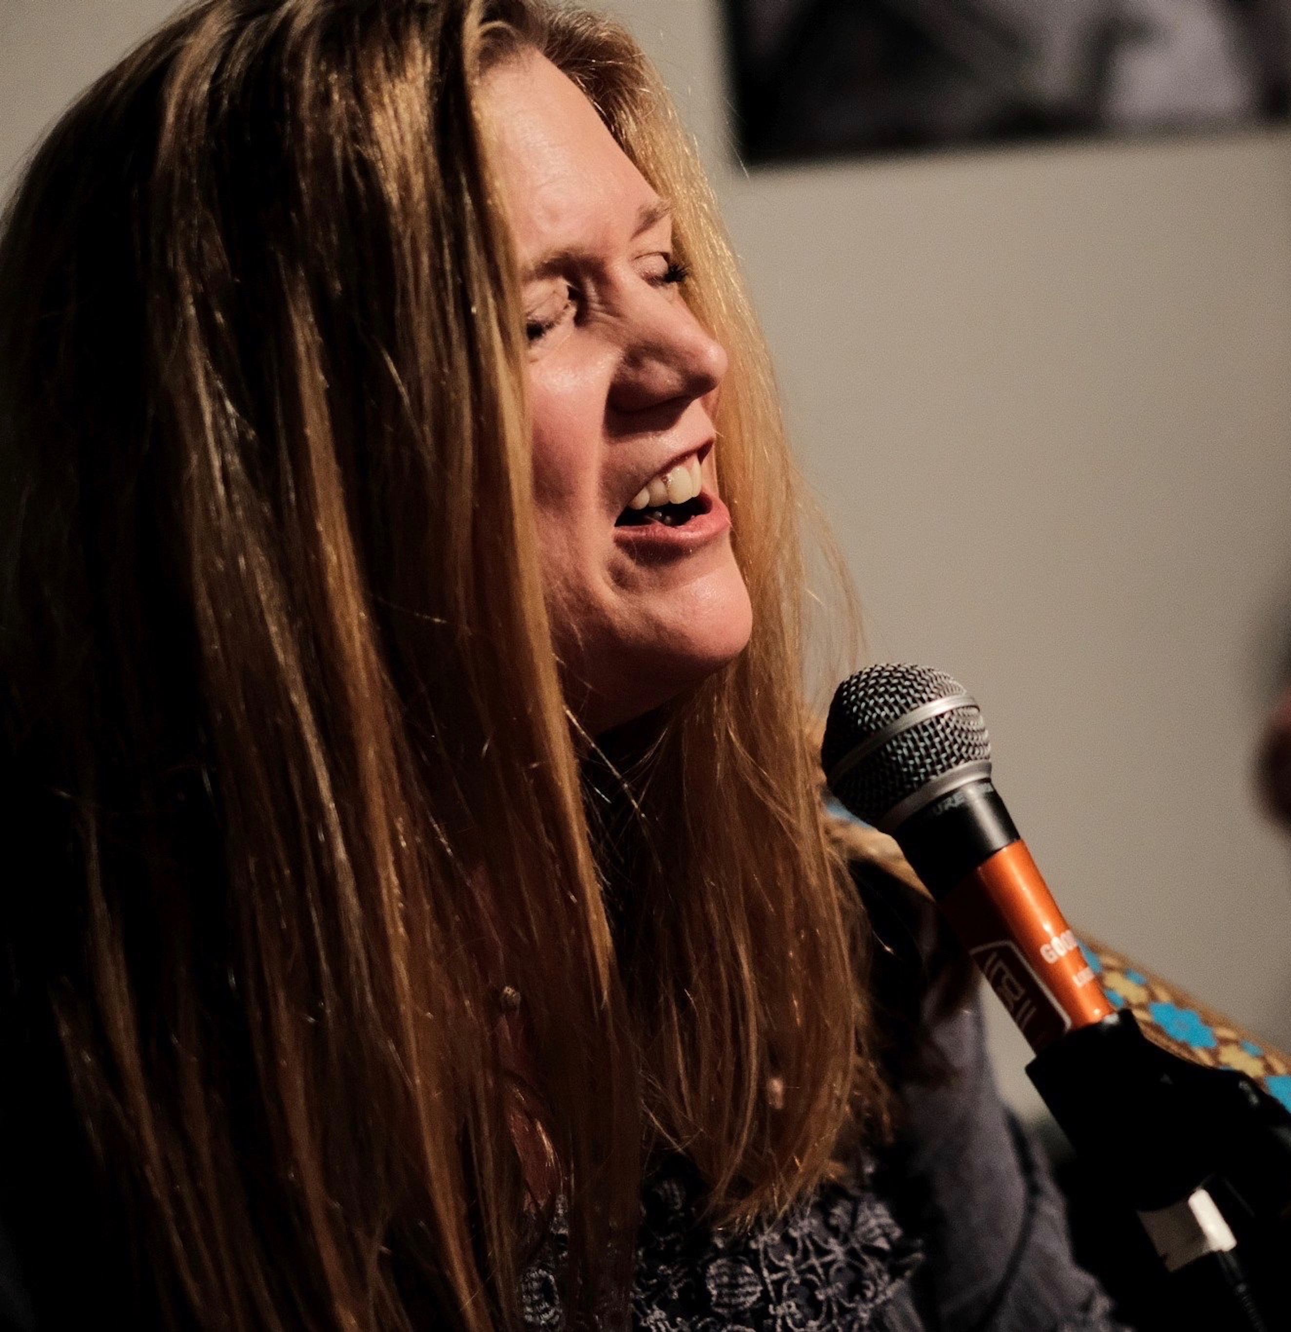

**About Marion**- Marion Halliday, a native Kentuckian now splitting her time between Louisville, Kentucky and Philadelphia, Pennsylvania, is proud purveyor of her own special blend of bluegrass and bourbon-infused, original, women-powered, Americana. While a highly regarded lead singer for many years in various Irish bands, Marion began focusing on performing her original music in 2016.  She released her debut solo EP, **Rings Around Saturn,** in July 2019.  That month, both the album and Marion (as artist) landed at #3 on the US/International Folk Radio charts (data compiled by Folk Alliance International-FAI); two songs from the album also landed in the top 10. The album was included by FAI in its 'Top Albums of 2019' list.

Covid put a stop to shows in 2020, but Marion has continued to write and record.  Check out her [newest music here](https://www.youtube.com/watch?v=yoK8JZxG-3k) on her youtube page (and please subscribe if so inclined!).

